Code Snippets from:
Exchange Server 2016 Book

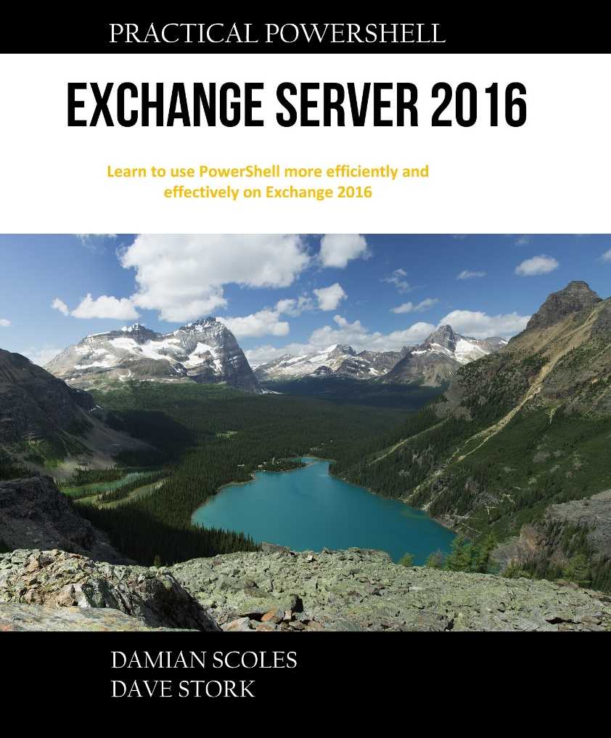

Introduction

Get-Mailbox | Get-MailboxStatistics

$Mailboxes = Get-Mailbox
Foreach ($Mailbox in $Mailboxes) {
Get-MailboxStatistics $Mailbox.Alias
}

Get-Mailbox | Get-MailboxDatabase

Get-Mailbox | Remove-Mailbox -WhatIf

Get-Command *mailbox*

Get-Command *database*

Import-Module ActiveDirectory

Get-Help Get-ExchangeServer

Get-Help Get-ExchangeServer -Full

Get-Database | Dismount-Database

Get-MailboxDatabase | Dismount-Database

Get-MailboxDatabase | Mount-Database

Get-Command *mobile*

Chapter 1
$Values = 1,2,3,4,5
$Names = “Dave”,“Matt”,“John”,“Michael”

$Hash = @ { }

$Servers = @{Dallas = ‘Exchange01’; Orlando = ‘Exchange02’ ; Chicago = ‘Exchange03’}

$CSVFileData = Import-CSV “C:\temp\MailboxData.csv”

$Mailbox = Get-Mailbox
If ($Mailbox -eq “Damian”) {
Set-Mailbox $Mailbox -ForwardingSMTPAddress DaveStork@PracticalPowershell.Com
}

If ($Quota -lt 2000000) {
Set-Mailbox $Mailbox -IssueWarningQuota 5gb
}

If (“Mouse” -lt “Wolf) {
Write-Host “The Wolf eats the Mouse!”
}

$CSVFileData = Import-CSV “C:\Data.csv”
Foreach ($Line in $CSVFileData) {
$DisplayName = $Line.DisplayName
$Size = $Line.MailboxSizeMB
Write-host “The user $displayname has a mailbox that is $Size MB in size.”
}

$Counter = 1
Do {
Write-Host “This is pass # $counter for this loop.”
$Counter++
} While ($Counter -ne 1000)
In the above sample, we use a counter

$Counter = 0
Do {
$Counter++
Write-Host “This is pass # $counter for this loop.”
} While ($Counter -ne 1000)

# Check for Old Disclaimers
Function Check-OldDisclaimers {
$RuleCheck = (Get-TransportRule).ApplyHtmlDisclaimerText
$RuleCheck2 = Get-TransportRule | Where {$_.ApplyHtmlDisclaimerText -ne $Null}
If ($RuleCheck -eq $Null) {
Write-Host “There are no disclaimers in place now.” -ForegroundColor Green
} Else {
Foreach ($Line in $RuleCheck2) {
Write-Host “There is a transport rule in place called $line that is a disclaimer rule.” -ForegroundColor
Yellow
}
}
} #End of the Check-OldDisclaimers function
Check-OldDisclaimers

Chapter 2
Function PagefileSizeCheckInitial {
}

Set-Mailbox –Identity UserA –PrimarySMTPAddress usera@contoso.com # Set Primary SMTP address

# Get-Mailbox DamianScoles | ft DisplayName, Server, Database
Get-Mailbox DamianScoles | ft DisplayName, ServerName, Database

$Mailbox = Get-Mailbox $Name
# Write-host “The current mailbox is $Mailbox.”

$Name = $SourceName.Split([Char]0x0020)

$Name = John, M., Smith
$Name = Michael, G, Larraday
$Alias = $Name[0]+$Name[2]
$Alias = JohnSmith
$Alias = MichaelLarraday

Write-Host "The server $name does not have the hotfix " -ForegroundColor White -NoNewLine;
Write-Host "$Hotfix" -ForegroundColor Red -NoNe

Write-Host "The server $name does not have the hotfix " -ForegroundColor White
Write-Host "$hotfix" -ForegroundColor Red
Write-Host " installed at this time." -ForegroundColor White

Foreach ($Name in $Names) {
Write-Host "The server $name does not have the hotfix " -ForegroundColor White -NoNewLine
Write-Host "$Hotfix" -ForegroundColor Red -NoNewLine
Write-Host " installed at this time." -ForegroundColor White -NoNewLine
}

$Current = "15.00.1178.004"
$CurrentMinus2 = "15.00.1130.007"
$Servers = Get-ExchangeServer
Foreach ($Server in $Servers) {
$Test = $Null
$ExchangeServer = $Server.Name
$Script = { $Ver = Get-Command Exsetup |%{$_.FileVersionInfo} }
Invoke-Command -ComputerName $ExchangeServer -ScriptBlock $Script
If ($Ver -eq $Current) {
Write-Host "The server $ExchangeServer is up to date [CU12]." -ForegroundColor Green
}
If (($Ver -lt $Current) -or ($Ver -gt $CurrentMinus2)) {
Write-Host "The server $ExchangeServer is within two CUs of being up to date [CU10 or CU11]."
-ForegroundColor Yellow
}
If ($Ver -lt $CurrentMinus2) {
Write-Host "The server $ExchangeServer is out of date. This means it is running 3 or more CUs
behind [CU9 or less]." -ForegroundColor Red
}
}

$Cert=(dir cert:currentuser\my\ -CodeSigningCert)
Set-AuthenticodeSignature .\MyScript.ps1 $Cert –TimeStampServer “http://timestamp.globalsign.com/
scripts/timstamp.dll”

Chapter 3
Get-ItemProperty -Path ‘HKLM:\SOFTWARE\Microsoft\NET Framework Setup\NDP\v4\Full’

(Get-ItemProperty -Path “HKLM:\SOFTWARE\Microsoft\NET Framework Setup\NDP\v4\Full”).Release

$DownloadFolder = “c:\install”
$File = “https://download.microsoft.com/download/E/4/1/E4173890-A24A-4936-9FC9-AF930FE3FA40/
NDP461-KB3102436-x86-x64-AllOS-ENU.exe”
$DownloadFile = $DownloadFile.Split([char]0x02F)
$DownloadedFile = $DownloadFile[-1]
Start-BitsTransfer -Source “$File” -Destination “$DownloadFolder\$DownloadedFile”

Start-Process ‘.\NDP461-KB3102436-x86-x64-AllOS-ENU.exe’ -ArgumentList ‘/quiet’,’/norestart’ –Wait

$DownloadFolder = “c:\install”
$File = “http://download.microsoft.com/download/2/C/4/2C47A5C1-A1F3-4843-B9FE-84C0032C61EC/
UcmaRuntimeSetup.exe”
$DownloadFile = $DownloadFile.Split([char]0x02F)
$DownloadedFile = $DownloadFile[-1]
Start-BitsTransfer -Source “$File” -Destination “$DownloadFolder\$DownloadedFile”

Install-WindowsFeature RSAT-ADDS
Install-WindowsFeature AS-HTTP-Activation, Desktop-Experience, NET-Framework-45-Features, RPCover-
HTTP-proxy, RSAT-Clustering, RSAT-Clustering-CmdInterface, RSAT-Clustering-Mgmt, RSAT55
Clustering-PowerShell, Web-Mgmt-Console, WAS-Process-Model, Web-Asp-Net45, Web-Basic-Auth,
Web-Client-Auth, Web-Digest-Auth, Web-Dir-Browsing, Web-Dyn-Compression, Web-Http-Errors, Web-
Http-Logging, Web-Http-Redirect, Web-Http-Tracing, Web-ISAPI-Ext, Web-ISAPI-Filter, Web-Lgcy-Mgmt-
Console, Web-Metabase, Web-Mgmt-Console, Web-Mgmt-Service, Web-Net-Ext45, Web-Request-
Monitor, Web-Server, Web-Stat-Compression, Web-Static-Content, Web-Windows-Auth, Web-WMI,
Windows-Identity-Foundation

If ((Get-WMIObject Win32_OperatingSystem).Version -NotMatch ‘6.2’)
If ((Get-WMIObject Win32_OperatingSystem).Version -NotMatch ‘6.3’)
If ((Get-WMIObject Win32_OperatingSystem).Version -NotMatch ‘10’)

If ((Get-WMIObject Win32_OperatingSystem).Version -NotMatch ‘6.2’) –and ((Get-WMIObject Win32_
OperatingSystem).Version -NotMatch ‘6.3’)) {
Write-Host “This server is not Windows Server 2012 or 2012 R2. Exiting.” -ForegroundColor Red
Exit
}

$OSVersion = (Get-WMIObject Win32_OperatingSystem).Version
If (($OSVersion -NotMatch ‘6.2’) -and ($OSVersion -NotMatch ‘6.3’) -and ($OSVersion -NotMatch ‘10’)) {
Write-Host “This server is not Windows Server 2012, 2012 R2 or Windows 2016. Exiting.”
-ForegroundColor Red
Exit
}

Get-Hotfix | Where {$_.HotfixID -eq “kb2919355”}

$Hotfix = Get-Hotfix | Where {$_.HotfixID -eq “kb2919355”}
If ($Hotfix -eq $Null) {
Write-Host “Hotfix kb2919355 is missing.” -Foregroundcolor Red
} Else {
Write-Host “Hotfix kb2919355 is installed.” -Foregroundcolor Green
}

$Hotfix = Get-Hotfix | Where {$_.HotfixID -eq “kb2919355”}
If ($Hotfix -eq $Null) {
Write-Host “Hotfix kb2919355 is missing.” -Foregroundcolor Red
} else {
DotNet461Install
}

Function Install-KB2919355 {
# KB2919355 Section
$DownloadFolder = “c:\install”
$SourceFile = https://download.microsoft.com/download/2/5/6/256CCCFB-5341-4A8D-A277-
8A81B21A1E35/Windows8.1-KB2919355-x64.msu”
$DownloadFile = $DownloadFile.Split([char]0x02F)
$DownloadedFile = $DownloadFile[-1]
Start-BitsTransfer -Source “$File” -Destination “$DownloadFolder\$DownloadedFile”
Start-Process “.\$DownloadedFile” -ArgumentList ‘/quiet’,’/norestart’ –Wait
} # End Install-KB2919355

$Hotfix = Get-Hotfix | Where {$_.HotfixID -eq “kb2919355”}
If ($Hotfix -eq $Null) {
Install-KB2919355
} Else {
DotNet461Install
}

Function DotNet461Install {
$DownloadFolder = “c:\install”
$File = “https://download.microsoft.com/download/E/4/1/E4173890-A24A-4936-9FC9-AF930FE3FA40/
NDP461-KB3102436-x86-x64-AllOS-ENU.exe”
$DownloadFile = $DownloadFile.Split([char]0x02F)
$DownloadedFile = $DownloadFile[-1]
Start-BitsTransfer -Source “$File” -Destination “$DownloadFolder\$DownloadedFile”
Start-Process “.\$DownloadedFile” -ArgumentList ‘/quiet’,’/norestart’ –Wait
} # End of DotNet461Install Function

Function DotNet461Install {
# Set the download folder for the .Net executable
$DownloadFolder = “c:\install”
# Set the file location to be downloaded
$File = “https://download.microsoft.com/download/E/4/1/E4173890-A24A-4936-9FC9-AF930FE3FA40/
NDP461-KB3102436-x86-x64-AllOS-ENU.exe”
# Split the file name up to remove the ‘/’ character
$DownloadFile = $DownloadFile.Split([char]0x02F)
$DownloadedFile = $DownloadFile[-1]
# Download the file
Start-BitsTransfer -Source “$File” -Destination “$DownloadFolder\$DownloadedFile”
# Install .Net 4.6.1 with the local file
Start-Process “.\$DownloadedFile” -ArgumentList ‘/quiet’,’/norestart’ –Wait
} # End of DotNet461Install function

<#
.SYNOPSIS
Install Exchange Server 2016 Prerequisites
.DESCRIPTION
Install Exchange Server 2016 Prerequisites using PowerShell
.NOTES
Version : 1.0
Change Log : 1.0 - First iteration
Rights Required : Local admin on server
Exchange Version : 2016
Author : Just A UC Guy [Damian Scoles]
Blog : http://justaucguy.wordpress.com
Disclaimer : No support provided by Microsoft
.EXAMPLE
.\Configure-ExchangePrereq-1.1.ps1
#>

$menu = {
write-host “************************************************”
write-host “Exchange Server 2016 PreRequisite Installation”
write-host “************************************************”
write-host “ ”
write-host “Please select an option from the list below:”
write-host “ ”
write-host “ 1) Prerequisites Part 1 - .Net and Windows Features”
write-host “ 2) Prerequisites Part 2 - UCMA 4.0”
write-host “ ”
write-host “ 98) Restart the Server”
write-host “ 99) Exit”
write-host “ ”
write-host “Select an option.. [1-99]?”
}

$Name = “16-lg-ex01.16-lg.local”
$Commands = (Get-Command | Where {$_.ModuleName -eq $Name}).Name
Foreach ($Line in $Commands) {
Get-Help $Line -Full > c:\downloads\command.txt
$Search = Select-String -Path c:\downloads\command.txt -pattern “cmdlet will be removed in a future
version of”
$Search2 = Select-String -Path c:\downloads\command.txt -pattern “cmdlet has been deprecated”
If ($Search -ne $Null) {
Write-Host “$line is going to be deprecated!” -ForegroundColor Yellow
}
If ($Search2 -ne $Null) {
Write-Host “$Line is going to be deprecated!” -ForegroundColor Yellow
}
Remove-Item c:\downloads\command.txt
}

Get-Command –Module A | Export-CliXml CmdletsA.xml

Get-Command –Module B | Export-CliXml CmdletsB.xml

$CmdA= Import-CliXml .\CmdletsA.xml
$CmdB= Import-CliXml .\CmdletsB.xml
Compare-Object -ReferenceObject $CmdA -DifferenceObject $CmdB -Property Name

Chapter 4
$LiveCred = Get-Credential
$Session = New-PSSession -Name ExchangeOnline -ConfigurationName Microsoft.Exchange
-ConnectionUri https://ps.outlook.com/powershell/ -Credential $LiveCred -Authentication Basic –
AllowRedirection
Import-PSSession $Session

$Cred = Get-Credential
$Session = New-PSSession -ConfigurationName Microsoft.Exchange -ConnectionUri http://<exchange
server FQDN>/PowerShell/ -Credential $Cred -Authentication Kerberos
Import-PSSession $Session

Get-PowerShellVirtualDirectory –Server 16-Tap-Ex01

Set-PowerShellVirtualDirectory “16-tap-ex01\PowerShell (Default Web Site)” -RequireSSL $True

Enter-PSSession -ComputerName LocalHost

Enable-PSRemoting

Get-User <Alias> | ft DisplayName,*power*

New-PSSession -ConfigurationName Microsoft.Exchange -ConnectionUri http://<exchange server
FQDN>/PowerShell/ -Credential (Get-Credential) -Authentication Kerberos
Get-PowerShellVirtualDirectory -Server <Exchange Server> | fl *auth*

Get-PowerShellVirtualDirectory -Server <exchange server> | Set-PowerShellVirtualDirectory
-BasicAuthentication $True

# Get list of all Exchange Servers
$Servers = Get-ADComputer -Filter *
Foreach ($Server in $Servers) {
$MemberOf = (Get-ADComputer $Server | Get-ADObject -Properties MemberOf).MemberOf
If ($MemberOf -Match “Exchange Install Domain Servers”) {
$Name = [string]$Server.Name
$ExchangeServers += ,@($Name)
}
}

$Server = $Args[0]

Write-Host “ “
Write-Host “Analyzing event logs for server $server” -ForegroundColor White
Write-Host “ “
Write-Host “PROCESSING” -ForegroundColor Yellow
Write-Host “ “

# Get a list of Critical Events
# Application Log
$Info = $Null
$App = $Null
$Log = “Application”

$LogCheck = Get-WinEvent -ListLog $Log -ComputerName $Server -ErrorAction SilentlyContinue

If ($LogCheck -ne $Null) {

Write-Host “Application Log Analysis” -ForegroundColor Cyan

$Events = Get-EventLog -ComputerName $Server -LogName $Log | Where {($_.EntryType -eq “Error”)
-or ($_.EntryType -eq “Warning”) -or ($_.EntryType -eq “Critical”)} | Sort-Object EventID | Group-
Object EventID

If ($Events -ne $Null) {

$App = Foreach ($Line2 in $Events) {
$Event = $Line2.Name

$Info2 = Get-WinEvent -ComputerName $Server -FilterHashTable @{LogName=$Log;ID=$Event}
-MaxEvents 1 -Erroraction SilentlyContinue
New-Object PSObject -Property @{
LastOccured = ($Info2.TimeCreated).DateTime
Count = $Line2.Count
Name = $Info2.ProviderName
Event = $Event
} Else {
Write-Host “No events were found.” –ForegroundColor Yellow
}

Chapter 5

